DATA STRUCTURE AND ALGORITHM
Exercise 2: E-commerce Platform Search Function
Product.cs
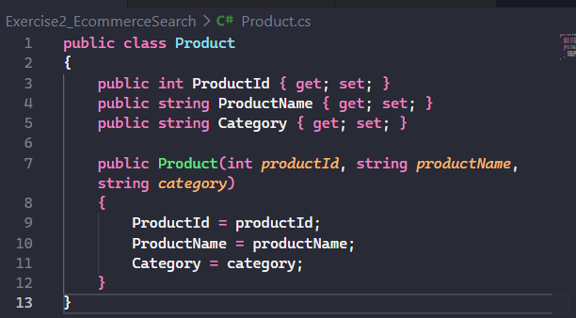
SearchOperations.cs
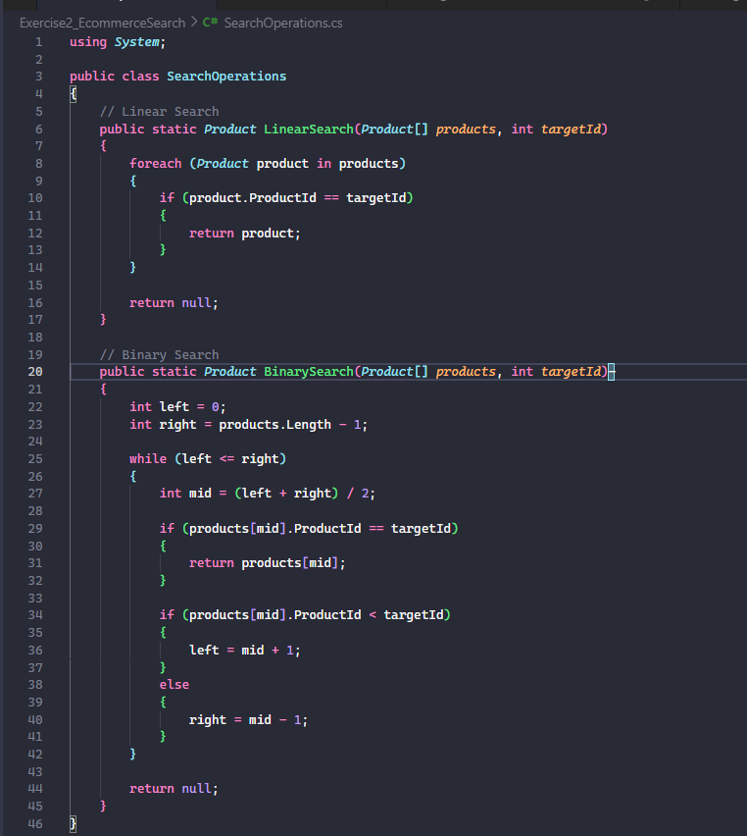
Program.cs
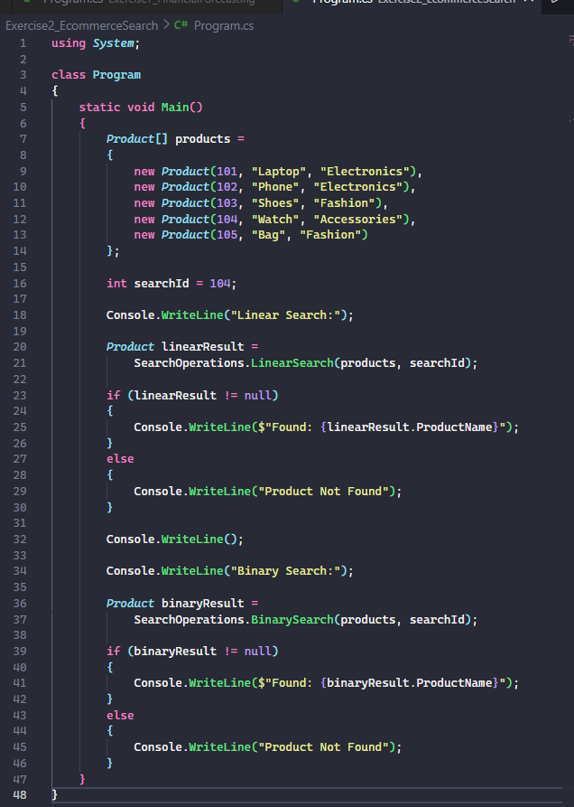
Output:
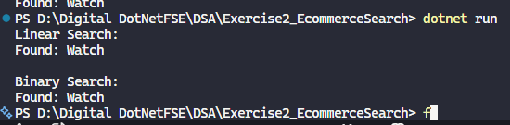

Exercise 7: Financial Forecasting
FinancialForcast.cs
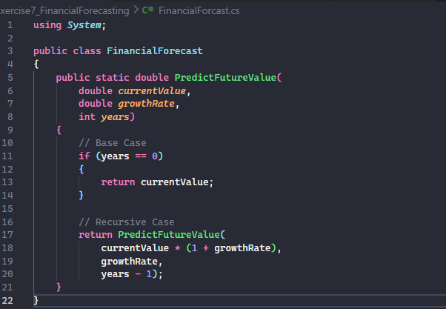
Program.cs
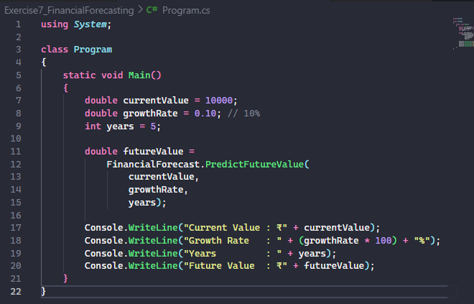
Output:
